Academic Standards and Quality Enhancement Bulletin
“Excellence in Higher Education Quality: One Shared Vision!
Office of the Academic Standards and Quality Enhancement (OASQE), Addis Ababa University, Addis Ababa, Ethiopia

Congratulations to the class of 2008 (E.C) of AAU, their families and beloved ones!!!

Academic Standards and Quality Enhancement Bulletin

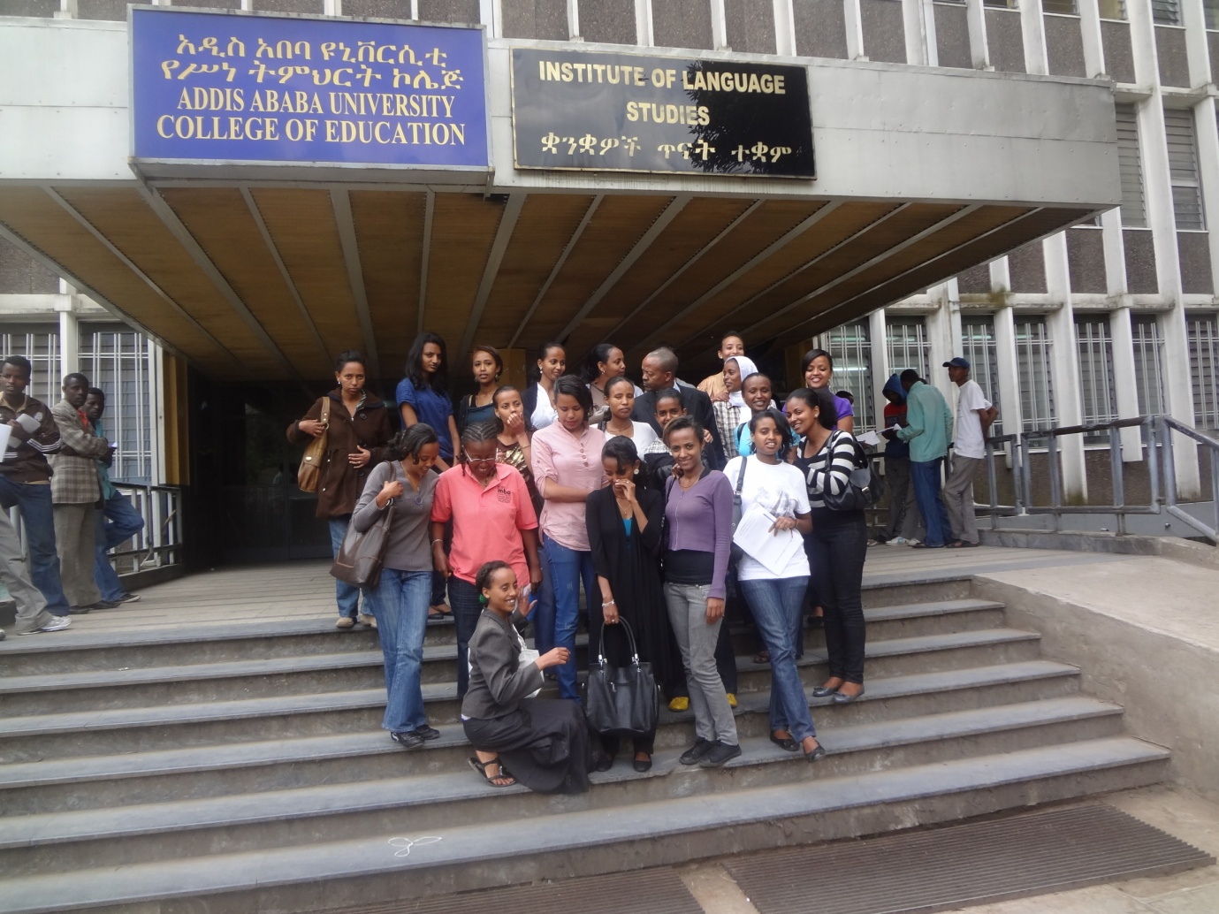
“Excellence in Higher Education Quality: One Shared Vision!
Office of the Academic Standards and Quality Enhancement, Addis Ababa University, Addis Ababa, Ethiopia
New Building, Room: 206 (Main/Sidist Kilo Campus)
Office Tele: 251-111-239756
Mobile: 251911608630
Website: www.aau.edu.et.
Email: mekasha_kassaye@yahoo.com
Fax: 251-111-239766 Ethiopia
Iune, 2016

Foreword

By AAU’s President, Admassu Tsegaye (PhD)
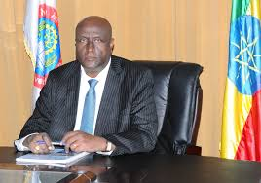
Quality in higher education is one of the top priorities of the Government of the FDRE.
Addis Ababa University, as a pioneer institution of higher learning, has a historical responsibility of both scaling its own quality high up in international standards and leading successive generations of universities to stride in its footstep. In light of this tremendous and lofty task ahead of AAU, the ASQE Office, AAU, is expected to play extremely decisive roles by way of addressing a number of educational standards and quality timely issues. Publishing up-to-date data on higher education such as in the form of this publication and disseminating the same to AAU community and its stakeholders and the wider community would help to regulate the quality of standards of services the AAU offers in terms of teaching, research and community consultancy. I would say, this publication is just a beginning, and there would ccome quite a lot in the future.
And I would like to reiterate the full support of the Office of the President to the Office of the Academic Standards and Quality Enhancement, AAU, in its endevours to execute its missions and responsibilities.

Editorial

We are pleased to welcome all our reders to the first ever formal publication of the Office for Academic Standards and Quality Enhancement, Addis Ababa University.
Needless to say that higher education in Ethiopia has made an impressive expansion in the last decade or so. And as a result we now find ourselves in a time when there are over 44 universities in the country. Many educational experts agree that the public services these universities render will live up to the expectations of both stakeholders and the community if the institutions are able to maintain set national and international higher education standards.
The Office for Academic Standards and Quality Enhancement, AAU, has been established with this grand responsibility of enabling the AAU to address educational quality issues at all levels in a maner that would meet the needs of the community. The Office has just started communicating educational quality issues with the University community and stakeholders with this publication. It is the Office’s conviction that publications like this would serve as a forum of professional dialogue on educational quality issues. We thus herby would like to invite the University community and all readers to contribute to future publications in various forms. The Office will continue and is committed to the service of the University community to streamline and orcastrate all efforts from all sides directed towards bringing about a world-class teaching-learning standard and qualityof graduates in AAU.
Join us in our motto, Excellence in Higher Education Quality: One Shared Vision!
The Editor.

Table of Contents
Foreword 3
Editorial 4
1. Office news in brief 7
2. Introducing the Office for Academic Standard and Quality Enhancement, AAU 10
2.1 Background 10
2.2 Vision 10
2.3 Mission 10
2.4 Goals 12
2.5 Core values 13
2.6. Structure 13
2.6.1 The Educational Management Information System Unit (EMIS) 13
2.6.2 Quality Management and Enhancement Unit (QMEU) 14
2.7. Tasks ahead of the Offcie 15
3. Addis Ababa University’s policy framework for academic standards and quality enhancement 16
3.1 Definitions 16
3.2. Purpose and scope 17
3.3. Policy statements 17
3.3.1. Efficiency and purposefulness 17
3.3.2. Quality core processes 17
3.3.3. Evidence-based approaches 17
3.3.4. Rigorous and continuous monitoring and evaluation 18
3.3.5. Transparency 18
3.3.6. Alignments 18
3.4. Reasons for the policy 18
3.5. Responsible Bodies 18
3.6. Implementation of the policy 19
4. Key information and statistical data about AAU 21
4.1. Useful teaching-learning standards from AAU’s 2013 legislation 21
4.1.1 Teaching and research load 21
4.1.2 Class size per section 21
4.2. Students enrollment in AAU by Colleges and institutions in 2008 E.C 22
4.2.1 Undergraduate and postgraduate Masters and PhD programs enrollment……………………..22
4.2.2 Post graduate diploma program enrollment (regular), 2008 E.C 24
4.2.3 A summary of overall students’ enrolment in 2008 E.C…………………………………...23
4.2.4 Prospective graduates of AAU for 2008 E.C. 25
4.2.4. AAU’s support staff profile 26
4.2. AAU’s faculty (academic staff), students and support staff profile by college/institute (2007 E.C)
4.3. AAU faculty’s (academic staff) qualification (2007.EC)
5. Annexes: 29
5.1 Important extracts from AAU’s document entitled “Guidelines for Program Design, Approval and Review “(2012). 29
5.1.1 Checklist that guides new program design and approval 29
5.1.2 Gidelines for programe self-evaluation 33
5.2. The UN SDGs (Sustainable Development Goals) to be met by 2030) 37
5.3. Names and contact information of current AAU’s management 38
6. Acknowledgements!! 42
Staff profile of the Office for Academic Standards and Quality Enhancement, AAU 43

Office news (ASQE) in brief

University-wide assessments on modularization and continuous assessment to be released soon
Survey studies conducted by the two groups of senior experts of the Office for Academic Standards and Quality Enhancement on modular and continuous assessment programs were finalized and final results are scheduled to be released beginning of September 2016. Cognizant of the timely introduction of the modular system of teaching and learning in Ethiopian public universities, the AAU, was one of the pioneers in successfully implementing the modular curriculum framework and its assessment modalities back in 2010 in its graduate programs and later in 2012 in its undergraduate programs.
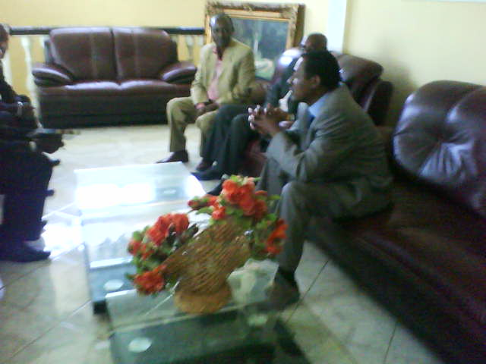
Jeilu Oumar (PhD), AVP, AAU, briefing management about the importance of introducing the modular approach in AAU.
The 2009 E.C action plan reaches finalisation
The Office of the Academic Standards and Quality Enhancement has finalized its 2009 E.C annual action plan. The action plan was developed within the framework of national development agendas and the AAU’s Five-Year Strategic Plan. Key activities planned in the action plan document are the step-by-step benchmarking of academic, research and consultancy service standards, staging series of seminars on quality mobilization in AAU under a theme called Quarterly Seminar Series on Quality in Higher Education, and development of a viable more effective organizational structure for academic standards and quality enhancement system in Addis Ababa University. High expectation from the AAU leadership and key stakeholders was felt as regards active participation from the AAU’s faculty and support staff and from key stakeholders to present research papers and informed talks on quality issues to promote university-wide dialogue and action on enhancing quality education.
UN 2030 SDGs dispatched to relevant university offices
In an intention to direct properly the focus of the university-wide effort to contribute to national development, the ASQE Office dispatched the UN Sustainable Development Goals (SDGs) (both English and Amharic versions), to which Ethiopia is a signatory, for reference and close observation to the University community and relevant offices. The SDGS were set to be in action as of 2015 and to be met all by 2030 the latest. It was disclosed that Goal No. 4 from the SDGs was especially set to bring about quality in education.

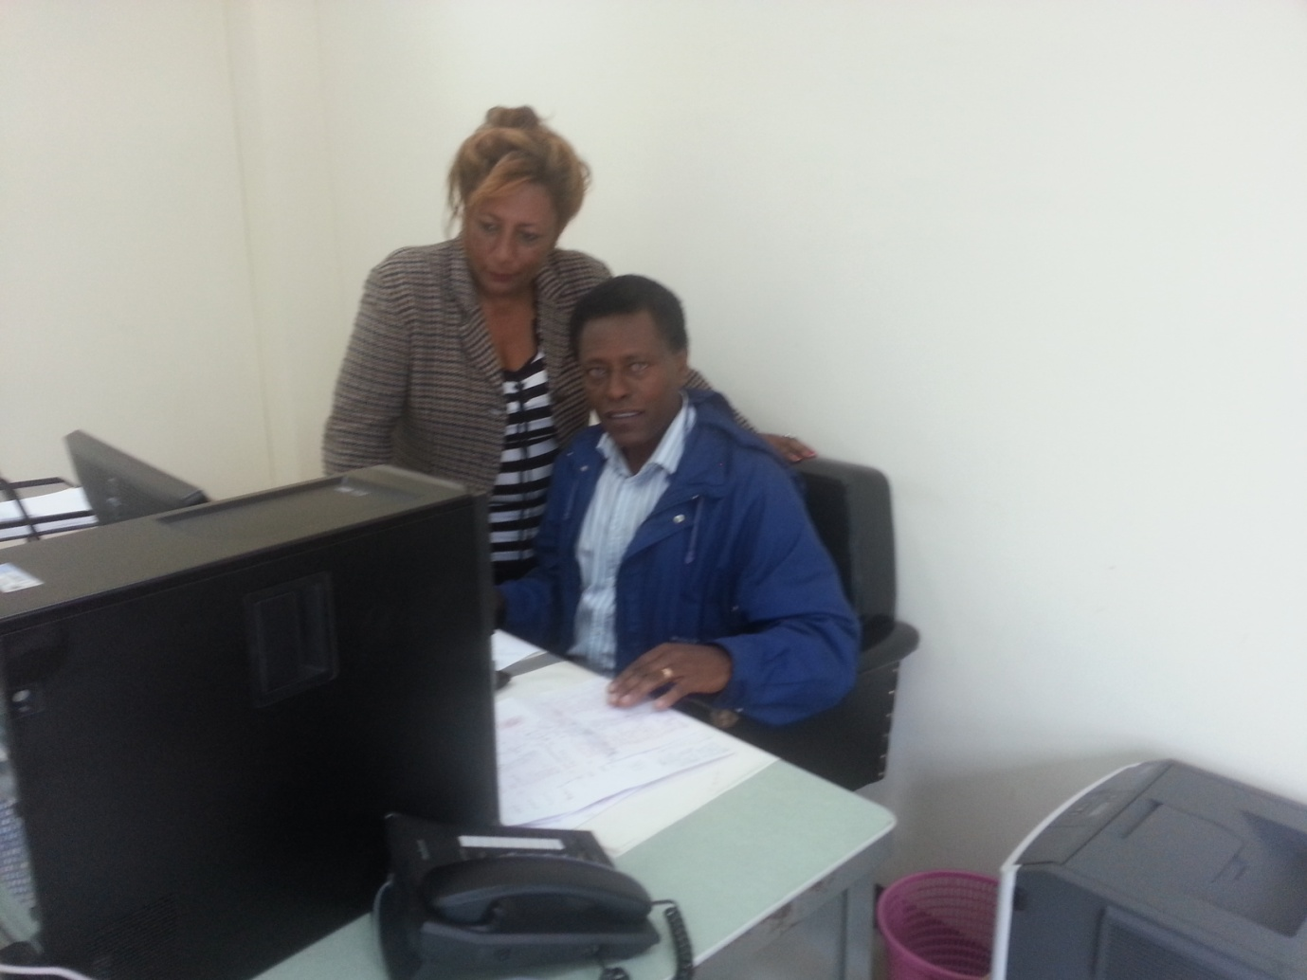

A new additional EMIS expert to be employed
Given the complexity of the quantitative and qualitative data the Office collects and the professional nature of computer software used to analyze, publish and disseminate those data, a need arose to employ a new EMIS expert with due qualification in ICT technology and statistical analyis. The Office in collaboration with the AVP of the University has finalized preparations to make the employment effective in an earliest time possible.
A preliminary student satisfaction survey kicks off in AAU
The AAU, through the Office of the Academic Standards and Quality Enhancement in collaboration with the Teaching-Learning Support Office, AAU, has conducted in June 2016 a preliminary student satisfaction survey in its undergraduate and graduate programs. A total of 2084 graduate and 6144 undergraduate students respectively, 30% from the total respective population, from all departments and colleges of AAU were expected to fill out the brief survey questionnaire comprising key elements of the University’s academic and facility service areas. Analysis of the survey data will soon be made and results are scheduled to be relseaed by the Offcie by October, 2016. The surevy was believed to be critcically instrumental in enhancing the quality of the teaching-learning in AAU.

2. Introducing the Office for Academic Standard and Quality Enhancement, AAU

2.1 Background
Ever since the AAU took a shape of modern academic institute, the formation of the Office for Academic Standards and Quality Enhancement in 2012 (staffed with experts in educational management and information system and quality management) was a breakthrough as the University aspires to be one of the top-tier graduate and research universities in Africa and as enhancing the quality of its programs is an indispensible task along with running various programs of studies. The Office is mandated by the University Senate, the highest University ruling body, to translate into action the quality enhancement policy the University developed and expedite all forms of efforts to improve educational quality in the University.

2.2 Vision
The OASQE vision and mission are consistent with the mission and vision of the Addis Ababa University and emanate from the AAU’s Quality framework policy.
OASQE, Addis Ababa University, aspires to be one of the the ten top-tier academic standards and quality enhancement offices in higher education in Africa in the coming few years leading the Addis Ababa University to commit itself to world-class benchmarks on higher education.

2.3 Mission
- Developing and progressively improving a holistic higher education quality policy framework for the University and ensuring that the same is properly implemented on the ground.
- Guiding, assisting and coordinating university-wide efforts to improve student learning via setting benchmarks of excellence/standards, developing quality audit plans, and quality management and enhancement documents.
- Developing a system and a capacity for AAU where evaluation of AAU-stakeholders partnership is conducted; evaluation of AAU graduates’ labor market is done; evaluation of AAU’s continuing education programs is made, and an evaluation of AAU’s students learning achievement against national standards’ for learning achievement and international achievement tests is carried out; and an evaluation of AAU’s outreach and community services is made.
- Digitalizing faculty and student evaluation /making them on-line/, data collection instruments/ on-line data collection/ instead of manual one/.
- Creating a monitoring mechanism wherein follow up can be done as to the proper implementation of all academic programs, research projects and community services, University-related rules and regulations from the University senate legislation down to specific department based rules, guidelines and regulations, adopting a viable educational quality management system.
- Enhancing institutional effectiveness and educational statistics in the way of assuring and enhancing academic quality and standards.
- Develop guidelines, instruments and measures of internal systems of quality enhancement;
- Developing quality standards and instruments informed by national and international quality norms to undertake academic audit on periodic basis.
- Leading and monitoring the development of strategies, policies and procedures, directing quality assurance and enhancement.
- Planning and leading academic programs development, approval and review processes; self-evaluation and ensuring that peer reviews of programs and academic units are conducted towards meeting acceptable standards of education.
- Coordinating and facilitating the academic review of teaching, learning, research and service.
- Enabling education duties to carry out their core activities effectively & efficiently
- Support colleges, departments and centers on enhancement of quality of education
- Coordinating and following up the international accreditation of programs of the university when necessary.
- Launching national and internationally partnerships with counterpart institutions so that it can best cater for the quality needs of the university and the public at large by learning from the experiences of other institutions.
- Promoting advocacy on higher education quality assurance using social media and traditional social community structures and indigenous systems.

2.4 Goals
Consistent with the AAU’s strategic plan, the OASQE will:
- Organize consultative workshops, conferences and regular forums of research and discussion on timely higher education quality issues.
- Revise regularly following developments in the field of quality assurance and consolidate its organizational structure and develop and revise its strategic plan so that the Office can fully and effectively address all educational quality issues of Addis Ababa University.
- Develop academic standards/benchmarks at the university level regarding, class size, teacher student ratio, lab set ups, qualification of faculty for teaching in the various programs, modularization, continues assessment, continuous professional development (CPD), graduate thesis supervision and examination, reputability of research journals, student academic codes of conduct, administration of authenticity tests (non-plagiarism tests), program design, approval and review, university level accreditation, instructional diversity management, affirmative actions, etc.
- Develop educational management information data bases, generate timely faculty and students related statistics, enrollment profiles, graduation and attrition profiles, and financial and resource utilization and management reports, revenue and expenditure sources, quality plans, quality audit instruments, quality assessment and evaluation questionnaires, manuals and guidelines, etc.
- Publish and disseminate reviews, reports, annual abstracts, program reviews, outcomes of researches on educational quality sponsored by the Office, and proceedings related to the above activities via physical means and electronic media such as webpage, and gather feedback and review feedback for further consumption.
- Forge working partnership with educational quality assurance offices nationally and internationally.
- Scale up the capacity of the Office by improving both the quantity and the quality of skilled workforce needed for fully running the missions of the Office through local and international training networks and educational programs.
- Equip the Office with state-of-the art IT logistics and communication infrastructure and networking facilities with partner institutions and organizations so that the Office can run its duties timely and abreast of time.
- Carry out surveys to measure the degree of AAU’s academic competitiveness with national and international universities and find out public attitude to AAU's educational quality.
- Monitoring the development of and setting the standards of exit examinations for graduates from the various academic units of the university.
- Monitor the development of and set the standards of graduate entrance examinations for applicants into the various academic units of the University.
- Conduct tracer studies and albour market surveys to collect feed back on the quality of AAU’s graduates and take necessary interventions as might be needed.
- Developing protocols for ensuring the quality of educational workshops and conferences the Addis Ababa University and the various academic units under it organize.

2.5 Core values

- Academic freedom
- Excellence
- Integrity and honesty
- Diversity
- Justice and fairness
- Evidence and scientific reasomning
- Dedication to quality

2.6. Structure
The ASQEO currently operates under the Academic Vice President of the University with all-round support from the University’s President and all Offices, Colleges, Research Institutes, and Centers. It has two program units: the educational amanagement information system unit and the quality management or enhancement unit.

2.6.1 The Educational Management Information System Unit (EMIS)
The EMIS deals with “a system for organizing information base in a systematic way for the management of educational development’ It is under this unit that educational information is collected, processed, analyzed, published, distributed and feedback is collected on the same for further use.

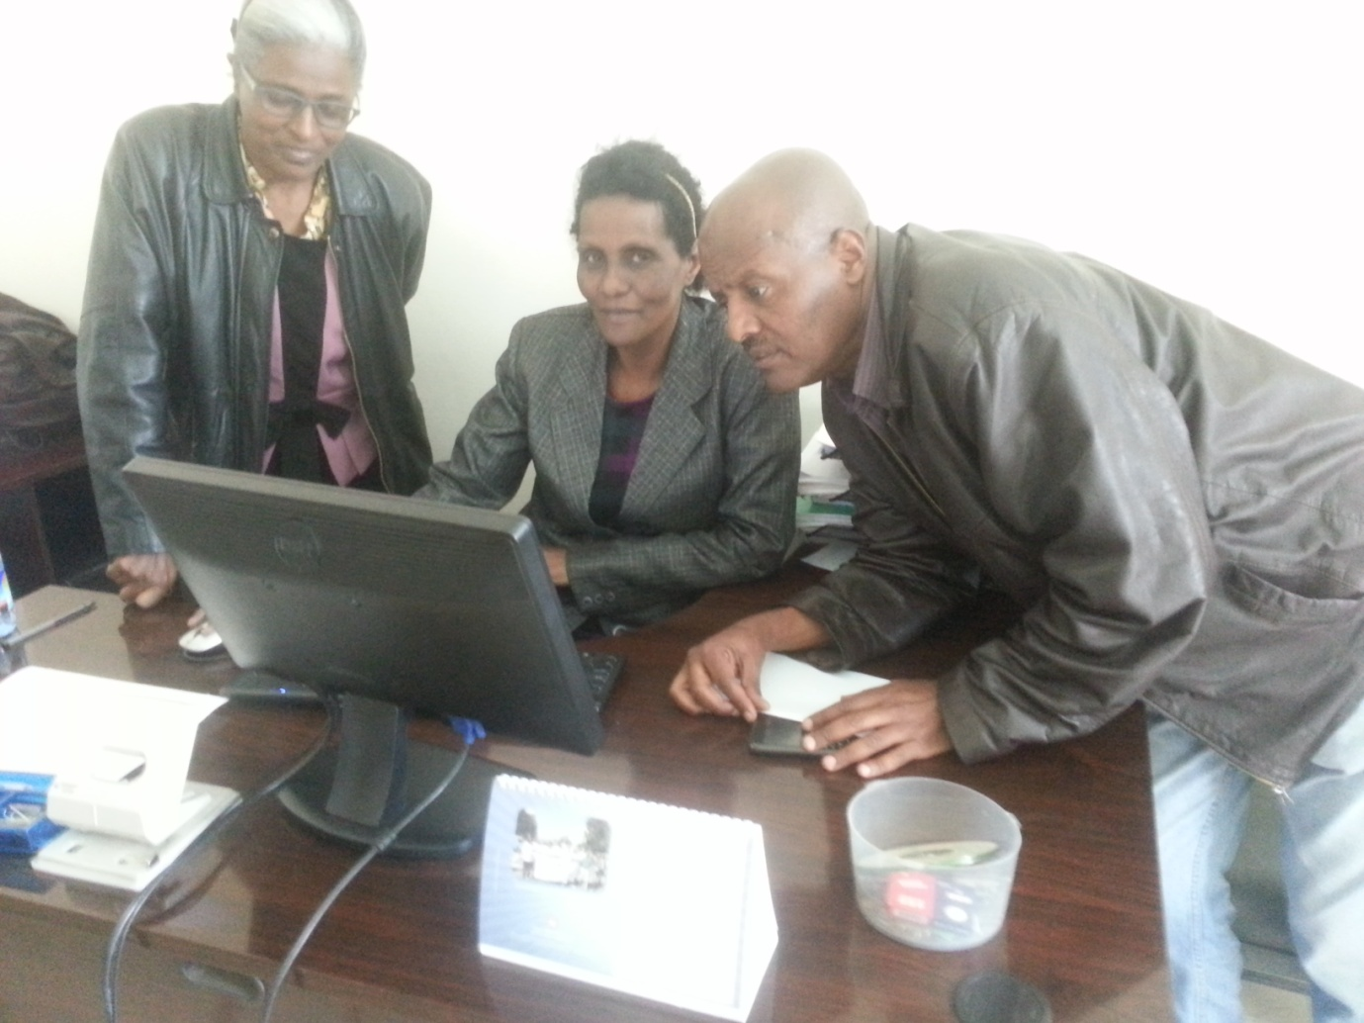
ASQE experts at work!

2.6.2 Quality Management and Enhancement Unit (QMEU)
This unit deals with the overall monitoring and evaluation of the proper implementation of AAU’s academic and non-academic rules and regulations, guidelines, procedures, codes of conduct, academic calendar, guidelines, directives, instructions, and the use of resources such as financial and physical such as academic infrastructures including resources with an intention that failure to implement these rules would jeopardize the overall educational quality in terms of teaching, research and consultancy services in Addis Ababa University.
The ASQEO works very closely with the various offices of AAU to secure up-to-date statistical information on AAU’s programs, faculty, students, and support staff.

2.7. Tasks ahead of the Office for Academic Standards and Quality Enhancement
After getting commented by the relevant experts and academic units and getting them approved by the University legislative organs, the Office will publish sets of handbooks containing quality audit instruments, guidelines, and standards and disseminate the same to both the university community and the public and follow up implementation and collect feedbacks as well on them for further improvement. To create an excellent working relationship with offices and partners outside the university, the Office will undertake self-promotional works such as sponsorships, free services, and advertisements.
The Office is committed to develop standards for performance, teaching learning, research and consultancy services, and good governance paying due attention to the context of the Addis Ababa University on one side and national and international experiences on the other side. To this effect, it will stage series of national and international workshops and conferences on academic quality issues from which it will secure inputs for developing its standards. It will design an organizational quality management structure that will enable it to get all the university community involved in quality matters and forward comments and useful expertise in various areas of studies and services.
The Office will also run series of regular quarterly seminars on the various higher education quality issues in consultation and in close collaboration with academic units and colleges in order to heighten the overall awareness of the University community on quality matters and thereby create sustained public mobilization on academic quality matters and introducing quality tracking systems. Finally, the office will soon run series of customer satisfaction surveys at the university level in order to know the level of satisfaction of faculty, students and staff, and key stakeholders with the academic programs , services, facilities, provisions and leadership of the University. It will publish information posters and sheets regarding the AAU’s status and performance.
The Office will continue to forge partnerships with local and international partners, government bodies, and non-government organizations and regulatory bodies in order to mediate its standards, share experience with and further build on the educational quality of the University.

3. Addis ababa University’s policy framework for academic standards and quality Enhancement

3.1 Definitions
The following concepts or phrases in connection with quality assurance (QA) are adapted in compliance with the terms and provisions in the BPR developed by the Addis Ababa University.
Academic Standards: are the expected levels of academic attainment used to describe and measure the academic requirements and performance of students at all levels and in all the programs of the University
Quality: the totality of the University’s effectiveness in its core processes and functions to satisfy stakeholder’s needs, priorities, and requirements (fitness for purpose); to fulfil requirements of relevance in transforming learners; and to be responsive for accountability purposes.
Quality Assessment: A periodic review and evaluation of programs, courses, instructional materials, teaching learning, and outcomes based on the BPR (Business Process Re-eingineering) requirements.
Quality Assurance: planned systematic, structured, continuous review and evaluation of all programs, courses, instructional materials, teaching, learning, assessment at the Univesity with the purpose of maintaining and improving these through continuous quality care efforts; and confirming the conditions are in place for students to achieve the standards set by the University and relevant national bodies (MoE/HERQA). It comprises all the systems, procedures, and processes directed at ensuring the enhancement of the quality and standards of the program course, instructional materials, teaching and learning effectiveness.
Quality Audit: A process of review of the University’s core process by HERQA or other agency to check that quality and relevance of the programs, curricula, staff infrastructure, and other elements meet the stated objectives and aims of the University and to determine the level of the University’s system of quality care and accountability.
Quality care: the University’s system to ensure that all its core processes are sound enough to enhance quality teaching and learning, research, and service delivery through permanent maintenance mechanisms.

3.2. Purpose and scope

In compliance with BPR requirements of the U niversity, the policy provides, defines, and guides the function, role, and responsibilities of all stakeholders with regard to supporting the University quality improvement efforts by drawing attention to the applicable guidelines, procedures, instruments on program development and review, assessment and evaluation of student teaching and course evaluation, and accreditation. It thus enhances the realization of the ideals of reform as encapsulated in the University’s Strategic Plan and the BPR.
The policy applies to all three levels ((undergraduate, masters, and PhD) and program across university in terms of program development and review; assessment and evaluation of student work; teaching and course evaluation and accreditation procedures

3.3. Policy statements
The following are the major elements of AAU’s policy on Quality Assurance:

3.3.1. Efficiency and purposefulness
AAU espouses the principle of ‘’less is more’’ where academic programs will be purposefully and efficiently organized to produce more value less time and resources giving more attention to national priorities.

3.3.2. Quality core processes
AAU aspires for quality programs, courses of study, instructional materials, teaching, learning, research and continuous improvement as core values. These values are intrinsic to the work of all faculty and staff, the leadership, and other stakeholders who undertake or support teaching and the promotion of learning and research.

3.3.3. Evidence-based approaches
The University believes in the central importance of evaluating its core process against appropriate national and international benchmarks. Its quality assurance methods are evidence-based, where outcomes and feedback from stakeholders (including students, staff, employers and alumni) will provide the basis for analyses and conclusions on which improvements are planned.

3.3.4. Rigorous and continuous monitoring and evaluation
The University commits itself to rigorously and continuously monitor and evaluate the effectiveness of its work processes and quality assurance procedures to ensure that they are operating in accordance with good practices in the best interests of all stakeholders and the maintenance of academic excellence which the university aspires to.

3.3.5. Transparency
Evaluations (formative as well as summative) of programs, courses, instructional materials, teaching and learning effectiveness will be transparent and participatory.

3.3.6. Alignments
This Policy aligns with the University’s mission, vision, and values which have been defined in the University’s Strategic Plan (2015).

3.4. Reasons for the policy
Addis Ababa University (AAU) is entrusted with the task of producing graduates of very high quality for the country in general and the expanding tertiary education in particular. In addition to this high responsibility vested in the University as a leading national institution, the changing landscape of higher education nationally and internationally has added urgency to the need to transform its core academic and support processes. Cognizant of these, AAU has entered into a process of radical transformation gearing all its efforts to assure quality teaching, learning, research, and service delivery through regular review and improvement process.
As one of its major transformation agenda, AAU is currently entering the implementation phase of the reform envisaged in its Strategic Plan (SP) and Business Process Re-engineering (BPR).
The reform transforms all the major functions of the university: teaching learning, research, and community services.

3.5. Responsible Bodies

Office for Academic Standards and Quality Enhancement
The primary purpose of the Office for Academic Standards and Quality Enhancement is to provide leadership in the coordination of university-wide efforts to improve student learning and enhance institutional effectiveness. The following are some of the specific responsibilities to be articulated in its vision, mission and objective statements.
- Coordinate and direct the development of strategies, policies and procedures directing quality assurance and enhancement to ensure that theses are mainatained, reviewd and.enhanced.
- Support Schools/Faculties, Departments, Program Units in quality care matters.
- Work in consultation with the campus community to establish, coordinate, and monitor the University’s assessment programs.
- Provide assistance for assessment conducted by academic departments as part of Academic Program Review.
- Coordinate and direct testing and assessment services.
- Provide assistance for assessment conducted by administrative units as part of the Support Unit Review processes.
- Establish and maintain a set of procedures which allow the University to respond in a systemic and transparent manner to the external requirements of External Audit Agencies.
- Ensure compliance with the University’s quality framework to meet required standards
- Ensure that a robust external examiner system is in place and clear procedures of examination and thesis defence are in place for all programs.
- Work with Faculties/Schools/Departments to provide professional advice and guidance on quality assurance and enhancement matters.
- Support enhancement of quality of education.
- Serve as a resource for the University community in its collective commitment to high level quality.

3.6. Implementation of the policy

Implementation of the policy includes critical self-evaluation; internal peer review; involvement of external disciplinary expertise; involvement of other external expertise/advice; involvement of students; involvement of faculties/schools/institutes; involvement of institutional leadership; involvement of alumni; assessment of interdisciplinary programs; and accreditation of all the programs. Consequently, each program, course, instructional materials, teaching and learning effectiveness is subject to periodic (formative) and summative evaluation and accreditations.

AAU's senic beauty!!

4. Key information and statistical data about AAU

4.1. Useful teaching-learning standards from AAU’s 2013 legislation

4.1.1 Teaching and research load

The teaching load of an academic staff shall be expressed in terms of Lecture Equivalent Hours
A Lecture Equivalent Hour (LEHs) is normally 1 credit hour or 1.7 ECTS, and a credit hour requires 3 hours of workload. The Credit Point in ECTS shall be equivalent to conventional credit hours or lecture contact hours. For this purpose, module/course credits, laboratory/practical/tutorial sessions, senior essay/project advising, and thesis/dissertation advising are expressed in terms of LEHs according to the following:

1 | One undergraduate course credit ……… ………………..… = 1.0 LEH
2 | One graduate course credit ………………………………….= 1.5 LEHs
3 | One hour lab/practical/ or tutorial session……………………=0.67 LEH
4 | One undergraduate student senior project/essay advising ….. =0. 40 LEH
5 | One graduate seminar/project advising………………………= 1.00 LEH
6 | One Ph.D. student Dissertation advising …………………….= 2.0 LEHs
7 | One Ph.D. student Dissertation Co-advising ……………… ..= 1.5 LEHs
8 | One Master’s Thesis advising ………….…………………….= 1.5 LEHs
9 | Co-advising for one Master’s Thesis………………………..…= 1.0 LEH
10 | Advising one medicine or veterinary student……………..........=0.5 LEH

4.1.2 Class size per section

The class size for courses offered on the basis of lecturing, tutorials and laboratory works shall be
as follows:

1 | Lecture type (Undergraduate)……………………… 40-50 students
2 | Tutorial and seminar classes(Undergraduate )………30-40 students
3 | Laboratory/Field session (Undergraduate)………….30-40 students
4 | For clinical attachment (Undergraduate). ………….15 students
5 | Lecture for graduate program (Master’s)…20-25 students
6 | Lecture for graduate program (Doctoral)…5-15 students

4.2. Students enrollment in AAU by Colleges and institutions in 2008 E.C

4.2.1. Undergraduate and postgraduate Masters and PhD programs enrollment

COLLEG/E/INSTITUTE | UNDERGRADUATE |  |  |  |  |  |  |  | POSTGRADUATE |  |  |  |  |  |  |  |  |  | Others(PGDT K& R)
 | REGULAR |  | EXTENSION |  | SUMMER |  | DISTANCE |  | REGULAR |  | EXTENSION |  | SUMMER |  | DISTANCE |  | PhD
 | F | M | F | M | F | M | F | M | F | M | F | M | M | F | F | M | F | M | F | M
A.A.U G.TOTAL | 6,292 | 14,167 | 3,853 | 7,829 | 1,100 | 2,724 | 48 | 92 | 1,288 | 3,861 | 939 | 3,326 | 344 | 2,277 | 163 | 522 | 160 | 1,703 | 178 | 1,501
Addis Ababa Institute of Technology | 1,266 | 4,826 | 513 | 2,519 | - | - |  |  | 244 | 1,190 | 118 | 807 |  |  |  |  | 2 | 67
Ethiopian Institute of Architecture and Building Construction and Development | 533 | 1,258 | 128 | 706 | - | - |  |  | 30 | 87 | 0 |  |  |  |  |  | 5 | 33
School of Information Science | 141 | 236 | 53 | 219 | - | - |  |  | 14 | 80 | 29 | 196 |  |  |  |  |  | 60
College of Natural Sciences | 671 | 1,220 | 112 | 269 | 349 | 1,512 |  |  | 147 | 383 | 33 | 235 | 115 | 944 |  |  | 62 | 400
College of Health Sciences | 1,053 | 2,053 | 326 | 296 | - | - |  |  | 226 | 732 | - | - |  |  |  |  | 1 | 67
College of Veterinary medicine and Agriculture | 290 | 743 | 325 | 409 | - | - |  |  | 12 | 42 | - | - | 7 | 23 |  |  | 5 | 56
College of Business and Economics | 823 | 1,952 | 1,839 | 2,433 | - | - | 48 | 92 | 148 | 294 | 314 | 1,113 |  |  | 148 | 499 | 3 | 67
College of Development Studies | - | - | - | - | - | - |  |  | 72 | 163 | - | - |  |  |  |  | 9 | 89
College of Education and Behavioral Studies (CEBS) | 170 | 162 | 110 | 162 | 156 | 600 |  |  | 127 | 257 | 264 | 522 | - | 192 |  |  | 15 | 213
College of Law and Governance Studies | 123 | 227 | 71 | 274 |  |  |  |  | 45 | 114 |  |  |  |  |  |  | - | 32
College of Social Sciences | 365 | 552 | 129 | 227 | 57 | 201 |  |  | 42 | 159 | 37 | 163 | 17 | 301 |  |  | 7 | 123
School of Social Work | 128 | 154 | - | - |  |  |  |  | 36 | 48 | 79 | 132 |  |  | 15 | 23 | 1 | 9
Center for African Studies | - | - | - | - |  |  |  |  | 14 | 23
College of Humanities, Language Studies ,Journalism and communication | 501 | 387 | 247 | 315 | 519 | 359 |  |  | 44 | 119 | 65 | 158 | 205 | 817 |  |  | 23 | 355 | 178 | 1,501
College of Performing and Visual Arts | 228 | 397 |  |  | 19 | 52 |  |  | 25 | 74
Institute of Educational Research | 0 | 0 |  |  | 0 | 0 |  |  | 58 | 78 |  |  |  |  |  |  | 12 | 77
Ethiopian Institute of Water Resource | 0 | 0 |  |  | 0 |  |  |  | 4 | 18 |  |  |  |  |  |  | 15 | 55

4.2.2 Post graduate diploma program enrollment (regular), 2008 E.C

College/institute/ school and department | Year I |  | Year II |  | Year III |  | Year IV |  | Year V and above |  | Total |  | G.Total
 | F | M | F | M | F | M | F | M | F | M | F | M
 | 43 | 139 |  |  |  | - | - |  | - | - | 43 | 139 | 182
Afan Oromo | 1 | 24 |  |  |  |  |  |  |  |  | 1 | 24 | 25
Amharic | 12 | 11 |  |  |  |  |  |  |  |  | 12 | 11 | 23
Biology | 4 | 13 |  |  |  |  |  |  |  |  | 4 | 13 | 17
Chemistry | 4 | 14 |  |  |  |  |  |  |  |  | 4 | 14 | 18
Civil | 2 | 9 |  |  |  |  |  |  |  |  | 2 | 9 | 11
Engilsh |  | 13 |  |  |  |  |  |  |  |  | - | 13 | 13
Geography | 3 | 11 |  |  |  |  |  |  |  |  | 3 | 11 | 14
History | 1 | 4 |  |  |  |  |  |  |  |  | 1 | 4 | 5
Mathematics | 2 | 16 |  |  |  |  |  |  |  |  | 2 | 16 | 18
Physical Education | 12 | 9 |  |  |  |  |  |  |  |  | 12 | 9 | 21
Physics | 2 | 15 |  |  |  |  |  |  |  |  | 2 | 15 | 17

4.2.3 A summary of overall students’ enrollment in 2008 E.C.
Program | Undergraduate |  |  | Postgraduate |  |  | Others |  |  | G.Total
 | Female | Male | Total | Female | Male | Total | Female | Male | Total
Regular | 6312 | 13897 | 20,209 | 1,496 | 5,448 | 6,944 | - |  | - | 27,153
PGDT | - | - | - | - | - | - | 43 | 146 | 189 | 189
Distance (Extension) | 48 | 92 | 140 | - | - | - | - | - | - | 140
Extention | 3855 | 7829 | 11,684 | 1,056 | 3,528 | 4,584 | - | - | - | 16,268
Summer | 1100 | 2724 | 3,824 | 801 | 5,858 | 6,659 | - | - | - | 10,483
G.Total | 11,315 | 24,542 | 35,857 | 3,353 | 14,834 | 18,187 | 43 | 146 | 189 | 54,233

4.2.4 Prospective graduates of AAU in 2008 E.C.

Program | Undergraduate |  |  | Postgraduate |  |  | Others |  |  | Oerall
 | Male | Female | Total | Male | Female | Total | Male | Female | Total | Male | Female | Total
Regular | 3396 | 1183 | 4579 | - | - |  | 146 | 29 | 175 | 3542 | 1212 | 4754
Extension | 1,411 | 579 | 1,990 | - | - |  | - | - |  | 1,411 | 579 | 1990
Regular (Ph.D.) | - | - | - | 262 | 9 | 271 | - | - |  | 262 | 9 | 271
Regular ( Masters) | - | - |  | 1,637 | 452 | 2,089 | - | - |  | 1,637 | 452 | 2089
Extension ( Masters) | - | - |  | 782 | 214 | 996 | - | - |  | 782 | 214 | 996
Summer (UG) | 312 | 181 | 493 | - | - | - | - | - |  | 312 | 181 | 493
Summer (Masters) | - | - | - | 466 | 42 | 508 | - | - |  | 466 | 42 | 508
Distance | 5 | 2 | 7 |  |  |  | - | - |  | 5 | 2 | 7
G.Total | 5,124 | 1,945 | 7,069 | 3,147 | 717 | 3,864 | 146 | 29 | 175 | 8,417 | 2,691 | 11,108

4.3. AAU’s faculty (academic staff), students and support staff profile by college/institute (2007 E.C)
S. N. | College/Institute/School |  | Under-graduate Sstudents | Post-graduate Students | Academic Staff | Administrative Staff
1 | Addis Ababa Institute of Technology |  | 9,124 | 2,428 | 375 | 550
2 | Ethiopian Institute of Architecture Building Construction and Development |  | 2,625 | 155 | 211 | 311
3 | College of Natural Sciences |  | 4882 | 2698 | 326 | 1460
4 | Institute of Geophysics, Space Science & Astronomy |  |  |  | 16
5 | Institute of Biotechnology |  |  |  | 28
6 | College of Health Sciences |  | 3,728 | 1,026 | 641 | 1430
7 | College of Veterinary medicine and Agriculture |  | 1,767 | 145 | 107 | 346
8 | College of Business and Economics |  | 7,187 | 2,586 | 227 | 368
9 | College of Development Studies |  | - | 333 | 57 | 106
10 | Ethiopian Institute of Water Resource |  | 0 | 92 | 8
11 | College of Education and Behavioral Studies (CEBS) |  | 1,360 | 1,590 | 120 | 68
12 | College of Law and Governance Studies |  | 695 | 191 | 55 | 38
13 | College of Social Sciences |  | 1813 | 1229 | 136 | 66
14 | College of Humanities Language Studies ,Journalism and communication |  | 2,328 | 3,465 | 179 | 136
15 | SB College of Performing and Visual Arts |  | 696 | 99 | 91 | 207
16 | Institute of Educational Research |  | 0 | 225
17 | Aklilu Lemma Institute of Pathobiology |  |  |  | 26
18 | Institute of Peace and Security Studies |  |  |  | 9
19 | Main Campus | Institute of Ethiopian Studies |  |  | 26 | 1261
20 |  | Institute of Development and Policy Research |  |  | 7
21 |  | Institute of Educational Research |  |  | 11
22 |  | Academy of Ethiopian Languages and Cultures |  |  | 23
23 |  | Addis Ababa University Libraries |  |  | 13
Total |  |  | 36,105 | 16,262 | 2692 | 6347

4.4 AAU faculty’s (academic staff) qualification (2007.EC)
Qualification | Female | Male | Total
 | N | N | N
Diploma | 13 | 49 | 62
Bachelor Degree | 92 | 335 | 427
Masters Degree | 170 | 1025 | 1195
PhD | 51 | 647 | 698
DVM | 1 | 9 | 10
MD | 74 | 225 | 299
Total | 401 | 2290 | 2691

Stakeholders: join us and advise us on!!

- Areas that need intervention in terms of quality enhancement in AAU!
- Best approaches to introduce to AAU’s context to maintain academic standards and higher education quality!
- Areas that are prone to academic corruption and thus to deteriorating quality!
- Strategies that would help us cope up with growing challenges to maintaining AAU’s educational quality and keep them up to the level of best practices!
- Our journey towards meeting international academic standards and thereby international accreditations, and by so doing this achieving excellence in higher education quality!

Your opinion matters!!!
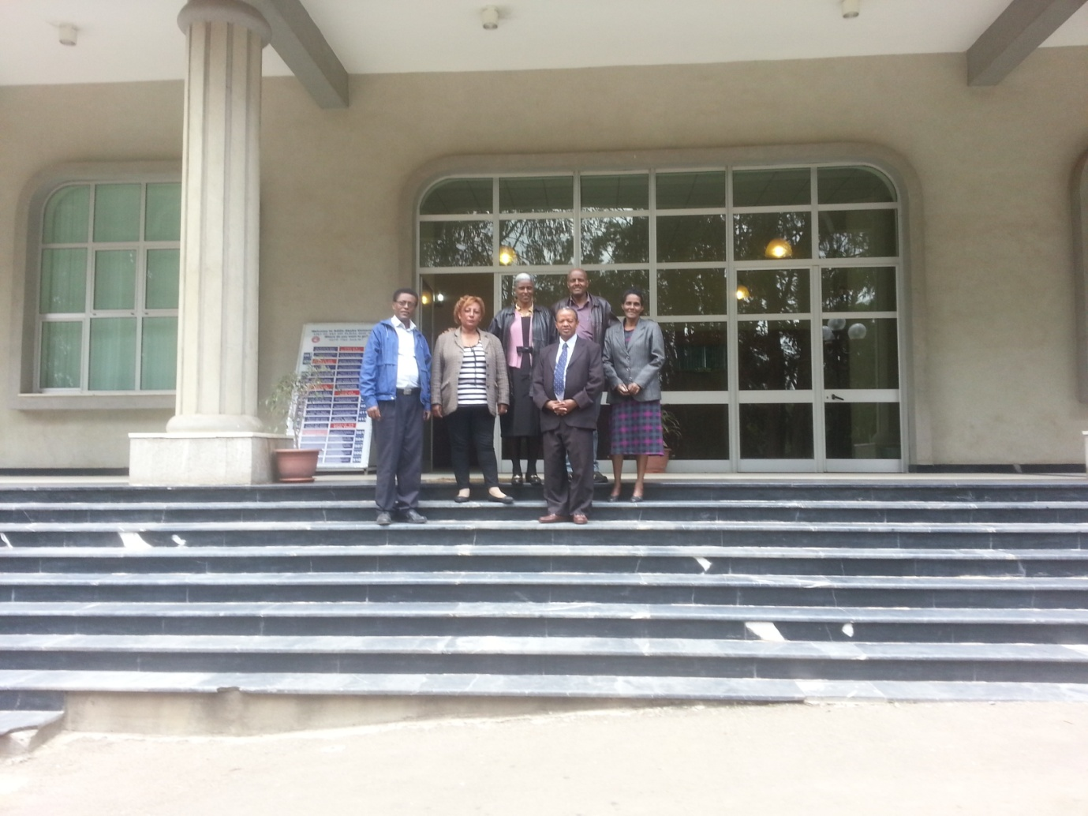
Staff of ASQE Office, 2008 E.C

“Our traditional ways are not adequate to deal with the quality crisis.”

______________________________________/////_____________________________

5. Annexes:

5.1 Important extracts from AAU’s document entitled “Guidelines for Program Design, Approval and Review “(2012).

5.1.1 Checklist that guides new program design and approval
The following checklist should be employed to review and approve new or modified programs.
Components | Questions | Answer
 |  | Yes | No
General | - Does the title or award reflect the aims and learning outcomes of the program?
 | - Do the steps followed in designing new program promote good practice?
 | - Does the program design consider the needs of stakeholders and students?
 | - Is there evidence that there is market demand for this program?
 | - Is the program distinct from the existing programs at Addis Ababa University?
Aims and learning outcome | - Are program aims and learning outcomes clearly stated?
 | - Are program learning outcomes aligned with aims?
 | - Do the learning outcomes clearly reflect the level of award?
 | - Has the alignment of program aims and learning outcomes with the university’s mission and national priority agendas been considered?
 | - Are the program expectations indicated in the intended learning outcomes realistic and deliverable?
 | - Are program aims and learning outcomes informed by subject benchmarks?
Program content & structure | - Are the content standards and structure set and specified appropriately?
 | - Are the relative demand, breadth, complexity and depth of study fit to the intended award of the program?
 | - Does program aims and content reflect current knowledge and research?
 | - Has the balance between academic and practical elements and opportunities been considered?
 | - Does the program encourage the development of an increasing intellectual challenge, skills, knowledge, and conceptualization among learners?
 | - Has the overall coherence of the modules of program been considered in the design?
 | - Does the program ensure the link between purpose of the program and the students’ learning experience?
 | - Does the content and structure enable students to achieve aims & learning outcomes?
Student Entry | - Does the new program consider the range of entry requirements for students?
 | - Does the program design give attention to arrangements for admission (e.g. disability & disadvantaged groups)?
Module descriptors | - Are the modules organized in such a way as to support student progression?
 | - Have the modules been structured in such a way that the requirements of all students can be supported?
 | - Does the module structure and sequence reflect overall coherence and intellectual integrity?
Teaching & learning | - Does the design incorporate a variety of teaching and learning methods that provide a range of learning environments for students?
 | - Has attention been given to the engagement and active participation of students in the selection of teaching methods?
 | - Does the selected teaching methods and learning opportunities enable students achieve program learning outcomes?
Assessment | - Does the design consider a range of assessment methods including formative assessment that enhance attainment of program learning outcomes?
 | - Does the assessment strategy adopted enable students to demonstrate achievement of learning outcomes?
 | - Do the assessment criteria enable students, teachers and external examiners to distinguish between levels of achievement?
Staffing | - Are the required number, qualification mix and experience of academic staff clearly indicated?
 | - Is the proposed qualification mix and expertise of staff appropriate to deliver the program?
Resources | - Are there appropriate learning resources available (infrastructure, library, laboratory, equipments, ICT, support services etc) to deliver the program?
Review | - Does the program design involve internal and external assessors?
 | - Have internal and external reference points been used in the design?
 | - Have adequate consultations been conducted with stakeholders?
Monitoring | - Has an evaluation strategy been indicated to judge the effectiveness and quality of program provision?
Student support strategies | - Is there a strategy to provide meaningful support to students including guidance & counseling, welfare support etc?
 | - Have the strategies and mechanisms for the development of learning resources and evaluation of the effectiveness of professional support services for teaching & learning been indicated

5.1.2 Gidelines for program self-evaluation
Guiding questions for self-study
Focus areas | Questions
Program mission, goals & rationale | - What is the mission and/or goals of the program? What plans & mechanisms are in place for achieving them?  - Are the mission and goals of the program communicated to and well known by staff and students?  - Are program mission and goals clearly defined and aligned with the mission and goals of the college or AAU? How?  - Why was the program created? Is the need for the program apparent in terms of AAU’s strategic plan and national priority agendas as well as market demand?  - What are the distinctive features of the program that makes it different from other or similar programs within the department, college, AAU and the country?  - Does the program reflect recent developments in the discipline and lead to sufficiently broad and well integrated knowledge and skills? How does the program address global issues?  - Does the program attain its mission and goals? Are there evidences for this?  - What are the weaknesses, opportunities and threats facing this program?
Curriculum | - How current and coherent is the program curriculum? Does it offer sufficient breadth and depth of learning for the degree award? Are the courses or modules well sequenced?  - What is the relevance and appropriateness of the curriculum to the discipline and program, college and university mission? To what extent does the curriculum cover important expertise and scholarly aspects of the discipline to meet program and labor market requirements?  - How well does it align with learning outcomes and graduate profile of students? To what extent does the curriculum equip students with appropriate knowledge and transferable skills and prepare them for employment and further study?  - How does the curriculum respond to changing demands and new direction in the discipline? How does the curriculum ensure that each graduate has the opportunity to achieve program goals?  - Is the curriculum flexible to allow innovation in teaching and learning? How dynamic is it?  - How does the curriculum compare to institutional, national and international standards? What are the gaps, strengths and weaknesses?  - How often has the curricula been reviewed in the past years? Has the program been reviewed by external stakeholder and measures taken to improve curriculum?
Teaching, learning & assessment |  | - What are the teaching learning strategies and methods used to enhance quality of student learning? How has technology been integrated into the teaching and learning process?  - Does the teaching and learning process encourage active participation and engagement of students?  - Does the program monitor its overall teaching effectiveness? How is teaching effectiveness evaluated?  - Are there evidences that show efforts to improve quality of instruction?  - Does faculty enjoy teaching the courses they teach? To what extent are teaching staff involved in student learning & development other than classroom teaching?  - How are teaching assignments made within the program and department? Does faculty have the appropriate expertise and teaching skill to deliver the curriculum?  - What mechanisms are in place to provide adequate academic advising to students and how well is it serving students’ needs?  - How are student learning outcomes assessed? What assessment standards and methods are in place? Are they being effectively utilized?  - Are the assessment system and methods appropriate to determine student achievement and attainment of program learning outcomes? Are improvements needed?  - To what extent does assessment promote student learning? Are there evidences for this?  - To what extent is the feedback from assessment results utilized to revise and improve curricula and pedagogy?
Faculty and staff |  | - Does the program have adequate, well qualified and committed faculty and support staff? Are the specialty, scholarship and teaching credentials of faculty appropriate to the discipline?  - What are the current faculty’s qualification mix and rank, faculty to student ration, gender mix and diversity? Are these adequate?  - What mechanisms and policies are in place to attract, recruit, promote and retain qualified faculty? Is there adequate professional development system to maintain faculty’s currency and scholarly interest in their field?  - How are faculty performance and productivity assessed? Is there adequate evaluation and reward system to maintain faculty’s engagement and moral?  - What is the overall effectiveness & professional contribution of faculty to the academic excellence of the program (as evaluated by students and staff)?  - What is the relevance and appropriateness of support and technical staff to the program mission and goals?
Student Progression & achievement |  |  | - How does the program recruit and admit students? Is there congruence between academic qualification of admitted students and program requirements?  - Are students achieving the desired learning outcomes at the expected level and in a timely fashion? What are the students’ retention, attrition and graduation rates? Is there a problem?  - What efforts are being made to create an intellectual and social climate that fosters the engagement, development and quality of student learning (e.g. internships, work-study, practicum, and clubs)? Are students prepared for advanced study of the world of work?  - How are the program’s expectations communicated? Are students kept informed of their progress in meeting intended learning outcomes?  - Do students receive adequate and appropriate advisement to help them progress toward program goals? Is student advising valued & rewarded? How is the quality of advising monitored and evaluated?  - How does quality of graduates of this program compare with graduates in similar programs? Are the evidences for this (e.g. student learning assessment results, tracer studies, current students or alumni satisfaction surveys etc)?  - Are improvements needed concerning student’s recruitment, admission, retention, engagement, learning and graduation?
Resources & support services |  |  | - Are sufficient resources (classrooms, operating expenses, workload, laboratory, library resources, equipment, instructional technology, and staff support) available and in working order to maintain program quality?  - How current and adequate are facilities, equipment, laboratory and other resources to improve program effectiveness?  - Are there adequate IT resources for sustaining the program? What is the degree to which the program has taken advantage of advancements in technology to enhance quality learning?  - To what extent do students and faculty have access to electronic learning resources?  - What mechanisms are in place to assist students with achieving their academic goals (e.g. tutoring and supplemental instruction, basic skills remediation, orientation and transition programs, counseling etc)?  - What are the strengths and gaps in available resources as they relate to the current program? Are improvements needed in this regard?
Research & scholarly activities |  |  | - What are the faculty’s research agenda, creative interests and aims? Are there documented evidences concerning major research projects, publications, research support, fellowships, grants, awards, commissions etc.?  - What is the level of students’ participation in faculty research? Are there research priority areas set by the program? How is this linked to improvement in teaching learning?  - To what extent are students’ research works (Master’s thesis and PhD dissertation) are linked to the title of the degree award? Are there problems?  - How is the program’s research work linked to the industry or other external stakeholders? Are there evidences of the show connections or collaboration with industry and other external organizations?  - What are the major impediments’ to faculty productivity in research exist and in what ways can these be improved?
Program governance & management |  |  | - How well is the program governed? To what extent does the governance structure support attainment of program mission?  - How are roles and responsibilities shared among faculty, staff, administration, committees and students in running and managing the program? How is the work and administration of the program allocated among faculty members?  - What is the level of faculty participation in collective decision making pertaining to program design, approval and review? Is shared governance encouraged and valued?  - What are the major structural and governance impediments that affect program quality?
Internal quality enhancement |  |  | - What internal mechanisms are put in place to enhance quality of the programs (e.g. program or curriculum or course review, research review, tracer studies, employer surveys, alumni surveys and feedback mechanisms)? Are there evidences of review over the past years?  - Are there standards and procedures for staff appraisal, assessment of learning outcomes and comparability of qualifications (e.g. self-assessment)?  - What are the gaps concerning the development and implementation of internal quality enhancement? What is needed to be improved?

5.2. The UN SDGs (Sustainable Development Goals) to be met by 2030

Goal 1. End poverty in all its forms everywhere.
Goal 2. End hunger, achieve food security and improved nutrition and promote sustainable agriculture.
Goal 3. Ensure healthy lives and promote well-being for all at all ages.
Goal 4. Ensure inclusive and equitable quality education and promote lifelong learning opportunities for all.
Goal 5. Achieve gender equality and empower all women and girls.
Goal 6. Ensure availability and sustainable management of water and sanitation for all.
Goal 7. Ensure access to affordable, reliable, sustainable and modern energy for all.
Goal 8. Promote sustained, inclusive and sustainable economic growth, full and productive employment and decent work for all.
Goal 9. Build resilient infrastructure, promote inclusive and sustainable industrialization and foster innovation.
Goal 10. Reduce inequality within and among countries.
Goal 11. Make cities and human settlements inclusive, safe, resilient and sustainable.
Goal 12. Ensure sustainable consumption and production patterns.
Goal 13. Take urgent action to combat climate change and its impacts.
Goal 14. Conserve and sustainably use the oceans, seas and marine resources for sustainable development.
Goal 15. Protect, restore and promote sustainable use of terrestrial ecosystems, sustainably manage forests, combat desertification, and halt and reverse land degradation and halt biodiversity loss.
Goal 16. Promote peaceful and inclusive societies for sustainable development, provide access to justice for all and build effective, accountable and inclusive institutions at all levels.
Goal 17. Strengthen the means of implementation and revitalize the global partnership for sustainable development.

5.3. Names and contact information of current AAU’s management

No | Name | Responsibility | Telephone numbers | E-mail address
1 | Admassu Tsegaye | President | 251-111-239752 | admasu.tsegaye@aau.edu.et
2 | Jeilu Oumer (PhD) | Academic Vice President | 0929366787 | ohjeilu@ymail.com
3 | Hirut Woldemariam (PhD) | Vice President for Institutional Development | 251-111-231084 | vpidcc@aau.edu.et
4 | Ato Zegeye Muluye PhD) | Vice President for Administration and Student Service | 251-111-239783 | Zegeye.muluye@aau.edu.et
5 | Tassew W/Hanna (PhD) | Vice President for Research and Technology Transfer | 251-111-239-769 | tasew.whana@aau.edu.et
6 | Yifru Birhan (Professor) | Executive Director for College of Health Sciences with the status of Vice President | 0911405812  +251 118 959 055 | yifruberhanm@gmail.com  health.sciences@aau.edu.et
7 | Esayas G/Yohannes (PhD) | Executive Director for Addis Ababa Institute of Technology (AAiT) with the status of Vice President | 0111-232435  0911244960 | gyisu@yahoo.com  esayas.gebreyouhannes@aait.edu.et
8 | Efrem G/Mariam(PhD) | Executive Director for Ethiopian Institute of Arrctecture and Building Construction (EiABC) with the status of Vice President | 0112-767605  0911609141 | eiabc@aau.edu.et  ephrem.gebremariam@eiabc.edu.et
9 | Ahmed Hassen (PhD) | Director, Institute of Ethiopian Studies | 0911242562 | Ahmed.hassen@aau.edu.et
10 | Belay Hagos (PhD) | Director, Institute of Education Research | 0911242543/0913766407 | Belay.hagos@aau.edu.et
11 | Mirutse Gidey (PhD) | Director, Aklilu Lemma Institute of Pathobiology | 0911242542 | mirutseg@yahoo.com
12 | Ataly Ayele (PhD) | Director, IGSSA | 0911401332 | atawon@yahoo.com
13 | Tesfaye Sisay (PhD) | Director, Institute of Biotechnology | 0910304449 | Tesfu74@yahoo.com
14 | Wondwossen Tesfaye (PhD) | Director, Academy of Languages | 0911002420 | Wond102@yahoo.com
15 | Prof. Zerihun Woldu | Director, Research Programs | 0911407255 | Zeirhun_woldu@yahoo.com
16 | Mulugeta Fesseha (PhD) | Director, Community Services | 0920192304 | mulugetafyg@gmail.com
17 | Ing. Wondwossen Bogale (PhD) | Director, University-Industry Linkage & TT | 0962270880 | wondeeebog@gmail.com
18 | Yakob Arsano (PhD) | Director, AAU Press | 0920192191 | Yarsano17@gmail.com
19 | Geremew Sahilu (PhD) | Director, Ethiopian Institute of Water Resource | 0911620361/0912109735 | gsahilu@gmail.com
20 | Getenet Alemu (PhD) | Director, Development and Policy research Institute | 0911529796 | galemu2001@gmail.com
21 | Gete Zeleke (PhD) | Director, Water and Land Res. Center | 0930014697/0911405930 | Gete_2004@yahoo.com
22 | Yoseph Mekonnen (PhD) | Director, President Office | 0911 244965 | yosmak@yahoo.com
23 | Com. Daniel G/Egziabher | Director, Standards, Safety and Security Office | 0912 374951 | kdanielg@yahoo.com
24 | Ato Wondimu Tadesse | Director, Office for Grievance Handling | 0911 100067 | wondimutadesse39@yahoo.com
25 | Ato Yonas Bekele | Director, Ethics and Anticorruption Office | 0911 812351 | yonishaman@gmail.com
26 | Ato Yosef Shiferaw | Director, ICT Office | 0911 244961 | yosef.shiferaw@aau.edu.et
27 | Ato Abraham Seyoum | Director, Change Management and Strategic Planning Office | 0911 898789 | abrasey2005@yahoo.com  strategic.plan@aau.edu.et
28 | Zenebe Beyene (PhD) | A/Director, Office of External Relations, Partnerships and Communications | 0911 229842  0911 516923 | bzenebe2000@gmail.com  external.relations@aau.edu.et
29 | Messay G/Mariam (PhD) | Director, Office of HIV Control and Prevention | 0911 981805 | mesghe@gmail.com  messay.gebremariam@aau.edu.et
30 | W/ro Almaz Tafesse | Director, Gender Office | 0911 944626 | ibsefir@yahoo.com
31 | Ato Mesfin Getachew | Head, Legal Services | 0911 457644 | gmesfin16@yahoo.com
32 | Ato Elias Tesfaye | Academic Vice President special Assistant | 0911642184 | elias.tesfaye@aau.edu.et
33 | Temesgen Burka (PhD) | Director, Academic Staff Affairs | 0911415726 | te.falu60@gmail.com, temesgen.burka@aau.edu.et
34 | Melaku Wakuma (PhD) | Director, Graduate Programmes | 0911500871 | m_wakuma@yahoo.com
35 | Demis Zergaw (PhD) | Director, Continuing and Distance Education Programme | 0911255108,  0920343550 | demiszergaw@yahoo.com
36 | Estifanos Ele (PhD) | Director,Teachig and Learning Supoort  ng -Learning SupportSupport Office | 0934985803 | elecheje@gmail.com
37 | Worash Getaneh (PhD) | Director, Undergraduate Programmes | 0911408768 | worash.getaneh@aau.edu.et
38 | Mekasha Kassaye (PhD) | Director, Office for Academic Standards and Quality Enhancement | 0911608630 | mekasha _kassaye@yahoo.com
39 | Bekele Abebe (PhD) | University Registrar | 0911242551 | registrar@aau.edu.et Bekelino_abe@yahoo.com
40 | Ato Mesele Berhanu | Deputy University Registrar | 0911466659 | mesele.berhanu@aau.edu.et  b.mesele @yahoo.com
41 | Ato Mesfin Gezahegn | Chief Librarian, Library & Academic Documentation Services | 0911242549 | mesfin.gabera@aau.edu.et

6. Acknowledgements!!

The Academic Standards and Quality Enhancement Office would dlike to extend its sincere gratitude to all Directors, Deans, Associate Deans, and Department Heads and officers who were so supportive and helping all throughout the development of this bulettin. Most of all, the Office of the Academic Vice-Predident of AAU and its entire industrious staff have to be immensely acknowldegd for their all-round support and keen interest dipalyed to see the outcome of the work. Finally, all experts of the Office for Academic Stanfards ansd Qualitry Enhancement must be acknowledged for their relentless effort excertted even beyond the call of duty to make this publication real.
We do hope you all will keep up working verly closely with us.
Cheers!!!

Staff profile of the Office for Academic Standards and Quality Enhancement, AAU

The ASQEO is headed by a Director and its entire professional services are rendered by six senior level experts divided into the two broad program units; namely, Educational Management Information System, and Quality Management and Enhancement Unit.
Director:
Mekasha Kassaye (PhD), Mekasha_kassaye@yahoo.com, mobile: 251-911608630
EMIS senior experts:
- Berhan Solomon, Berhan.Solomon@aau.edu.et, mobile: 09-11-44-48-55
- Getachew Benti, getachew.benti@aau.edu.et, mobile: 09-11-48-33-23
QMEU senior experts:
- Amarech Tadesse, amarech.tadesse@aau.edu.et, mobile: 09-1130-88-58
- Bekele Gikamo, bekele.gikamo@aau.edu.et, mobile: 09-13-57-65-44
- Mekdes Yilma, mekdes.yilma@aau.edu.et, mobile: 09-12-10-83-50
- Tabi Asfaw, tabi.asfaw@aau.edu.et, mobile: 09-13-61-26-01

Front view of the President’s Office, |AAU main campus !

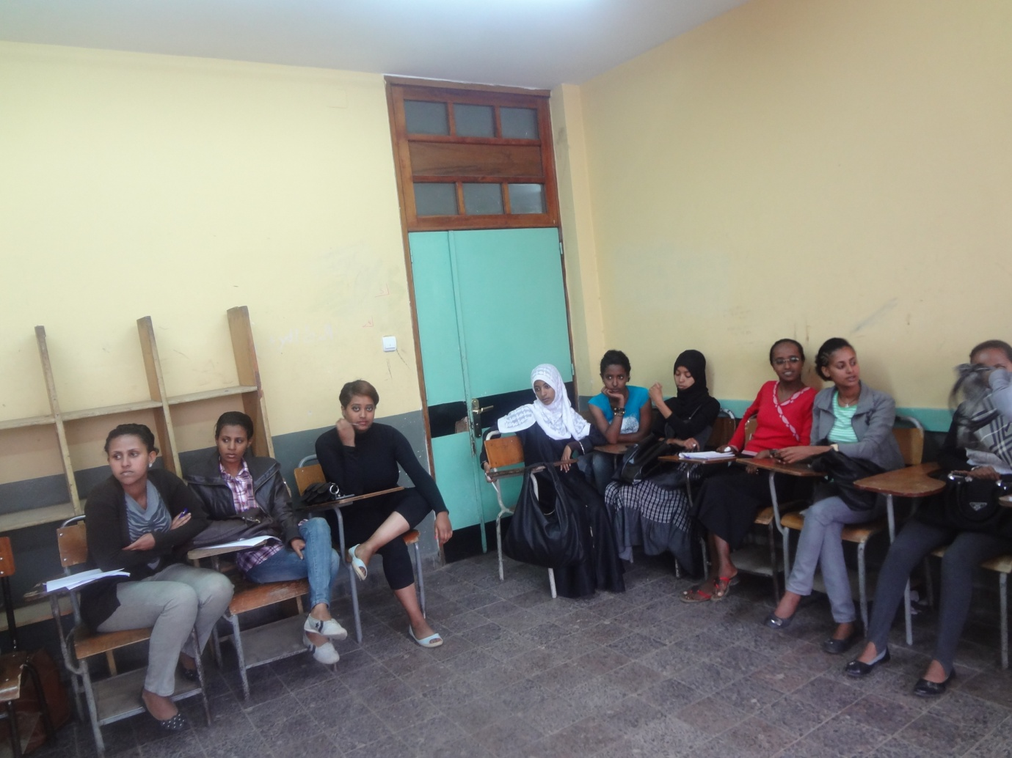
AAU graduate students in class !

